Music Player V 1.0.1
Software Development | Programming III

EROL A’NIL

2021

Table of Contents
Software Development | Programming III 0
Testing 2
Debugging 2

Testing

Action | Expected Output | Actual Outcome
Add Button | Adds Files | Expected | 1 & 1-1 Pictures
Play First | Plays the 1st Song | Expected | 2 Picture
Play Last | Plays the Last Song | Expected | 3 Picture
Play Previous | Plays the Previous Song | Expected | 4 Picture
Play Next | Plays the Next Song | Expected | 5 Picture

Debugging

Debugged on Next Button which show below screenshots.

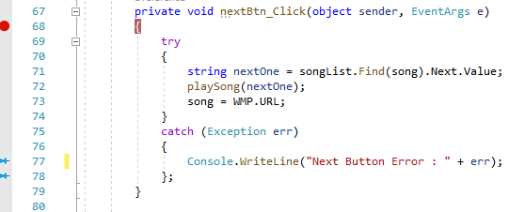
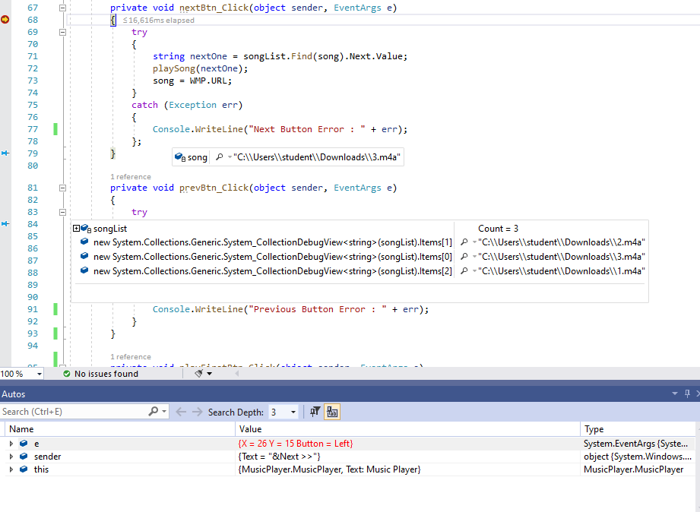

Issue occurs when the next node is null. But can be fixed by implementing an if statement. If next node is null give an alert message “ There is no next song”.

